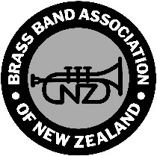

***Brass Band Association of New Zealand National Championships***

**DECLARATION OF ASSISTING MUSICIANS**

BAND NAME:

In line with Contest Regulation 10.4, we will use the following Assisting Musicians during the 2025 National Brass Band Championships.

|  |  |  |
| --- | --- | --- |
|  | **Player’s name** | **Band registered with** |
| Brass only |  |  |
| Brass only |  |  |
| Percussion only |  |  |
| Percussion only |  |  |
| Marching Only |  |  |
| Marching Only |  |  |
| D Grade Only Player can only be from a C and D Grade band |  |  |
| D Grade Only Player can only be from a C and D Grade band |  |  |

Signed on behalf of the Band making the declaration: Please print name:

Position in the organisation: Date:

Please email to [bbanzeo@gmail.com](mailto:bbanzeo@gmail.com) or post to Brass Band Association of New Zealand 159 Gayhurst Road, Dallington, Christchurch 8061 so as to arrive before Friday 27 June 2025 or hand it into the Contest Office in Christchurch before the Assisting Player/s take the contest stage.